WEEK 4 DAY 2 TASK 2
SNOWFLAKE
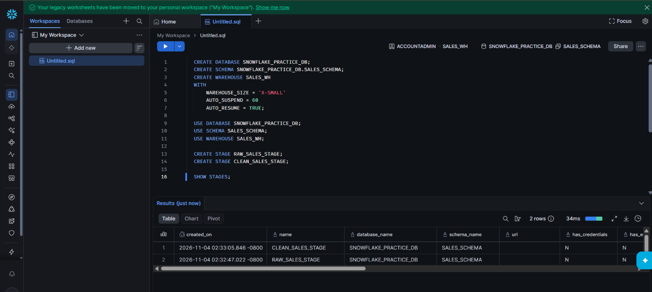
CREATED DB , SCHEMA , WARHOUSE AND STAGES

CREATE FILE FORMAT
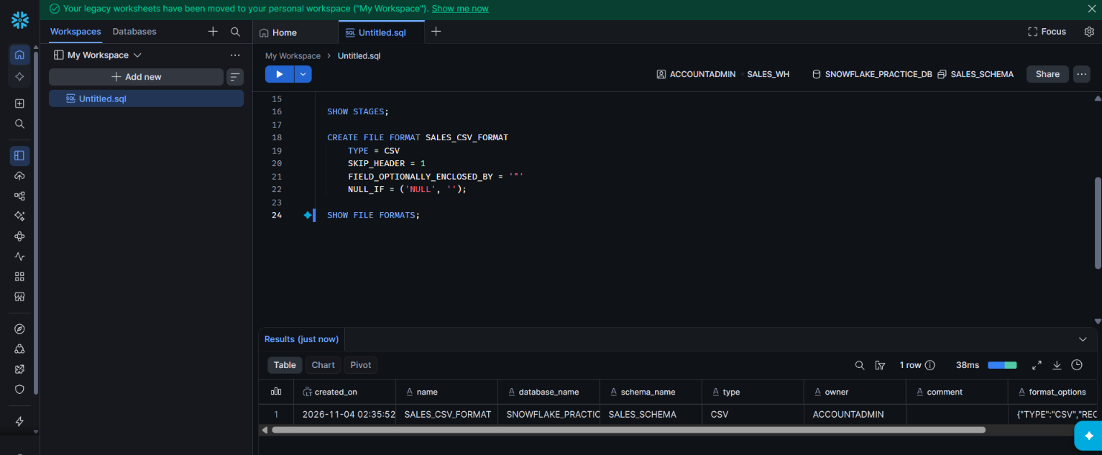

Upload raw file in raw stage
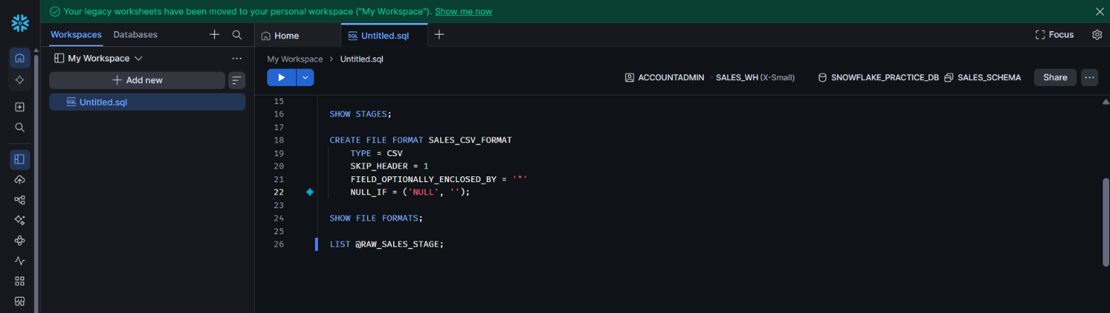
Create raw sales table
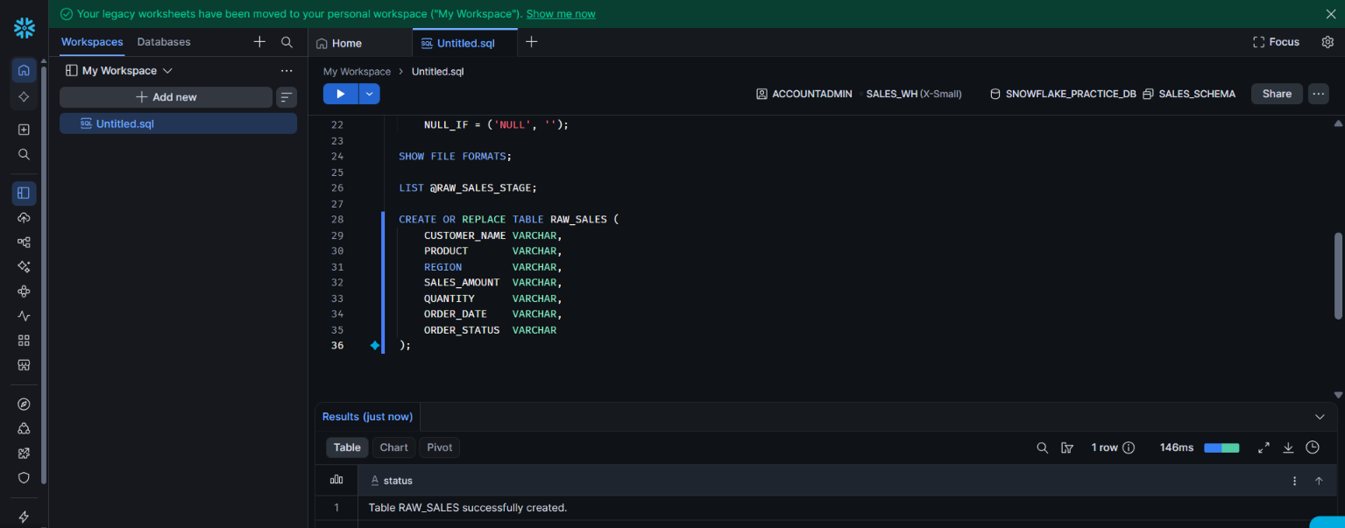

Loading the data using copy into
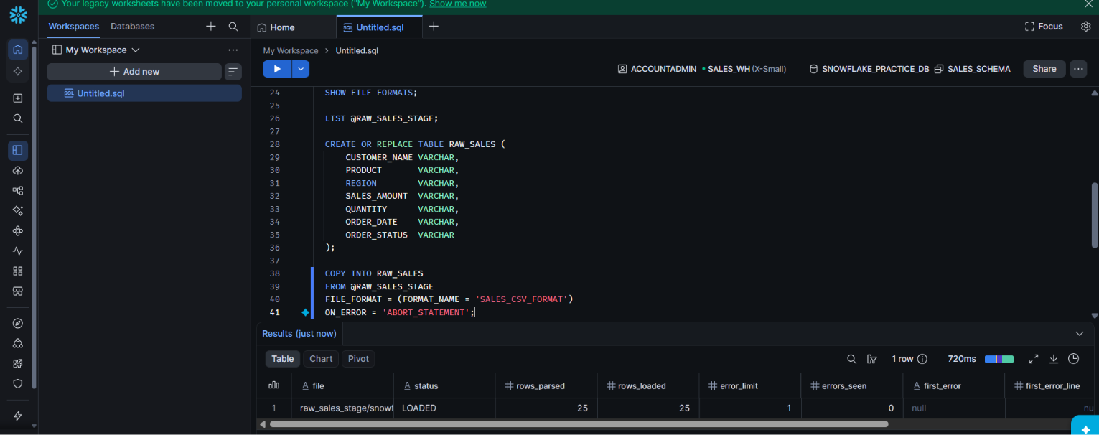

Inspect messy data
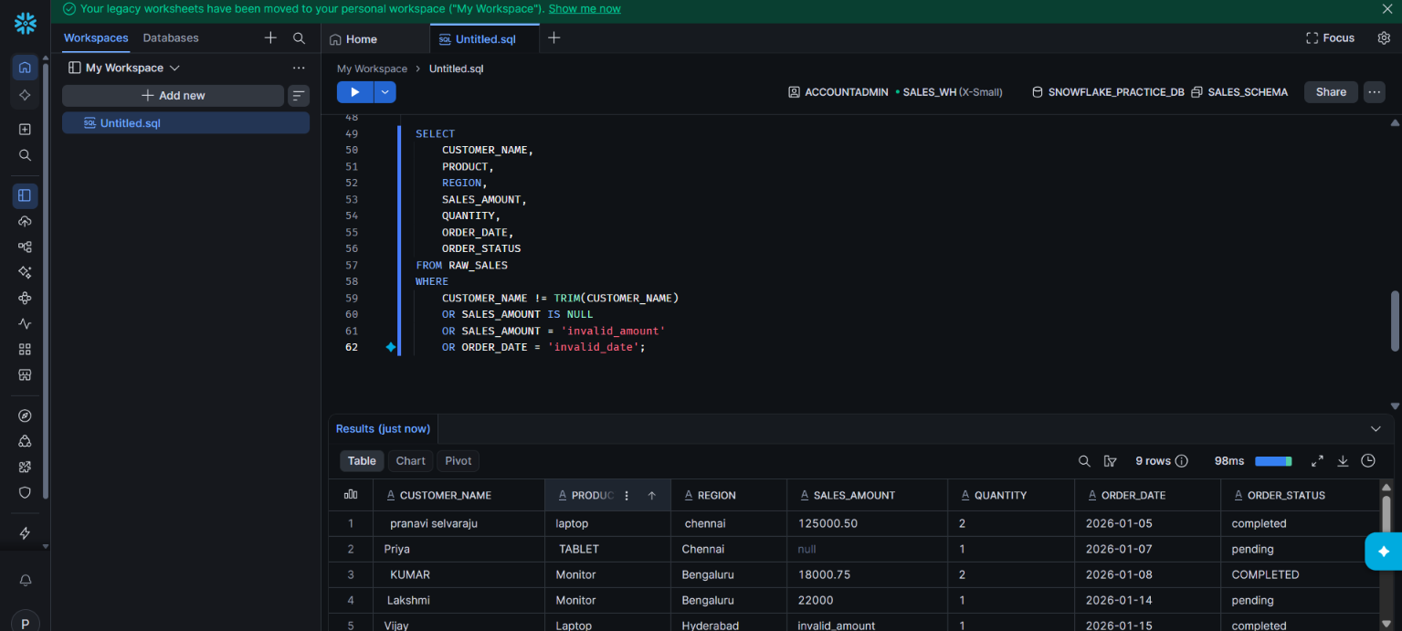
Create clean sales table
And performing the data ttransformation like
• TRIM() — remove extra spaces.
• UPPER() — standardize names, products, regions, and statuses.
• COALESCE() — replace missing values.
• CASE — classify sales and normalize statuses.
• TRY_CAST() — safely convert numeric data.
• TRY_TO_DATE() — safely convert dates.

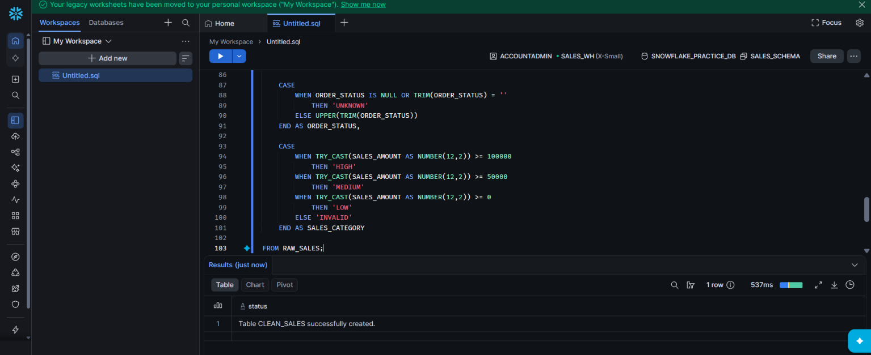
Checking the cleaned data
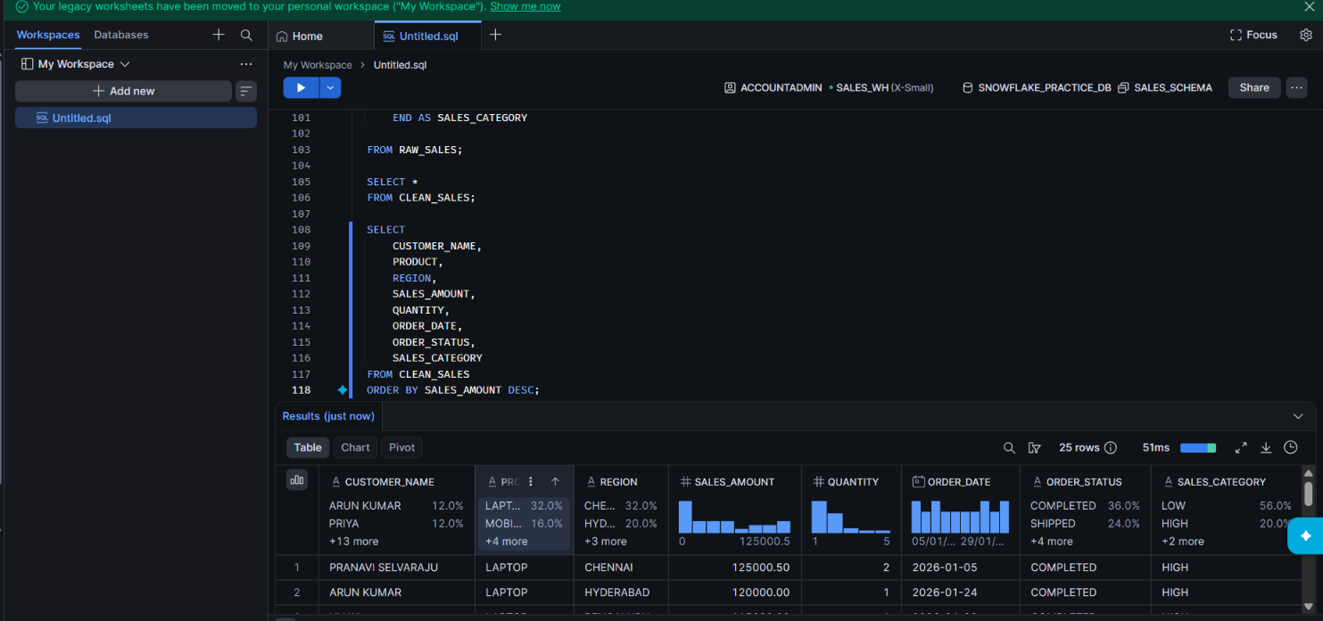
Now the datas are cleaned
Checking data quality
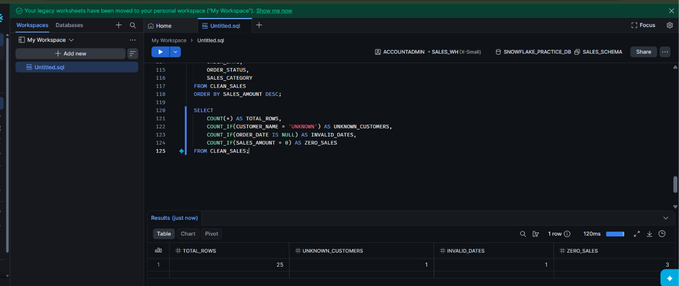
Creating csv file for export
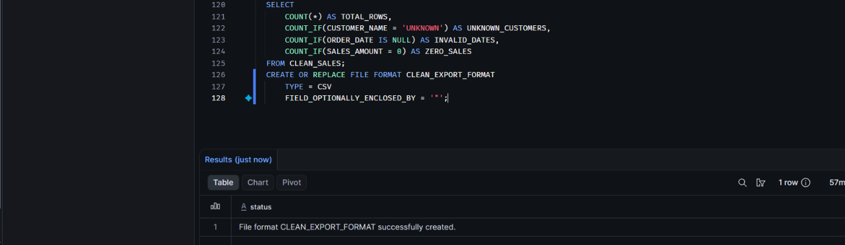
Export the clean table
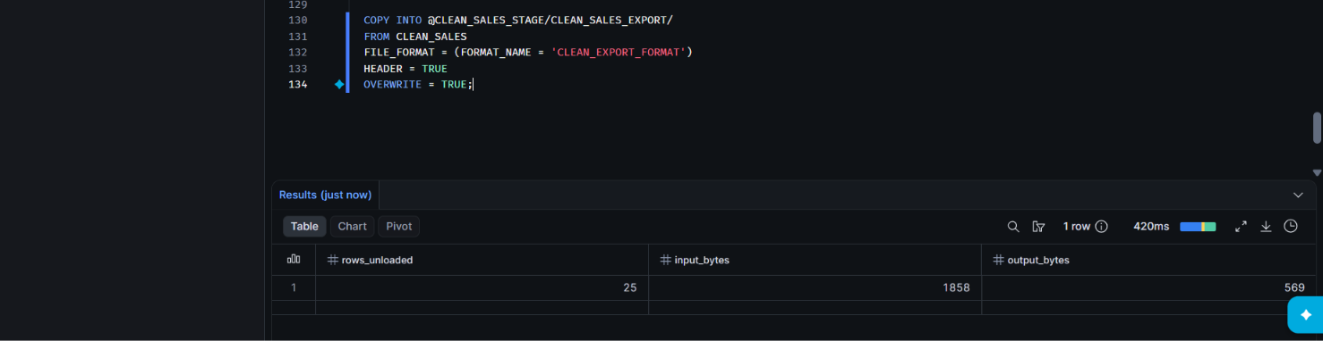
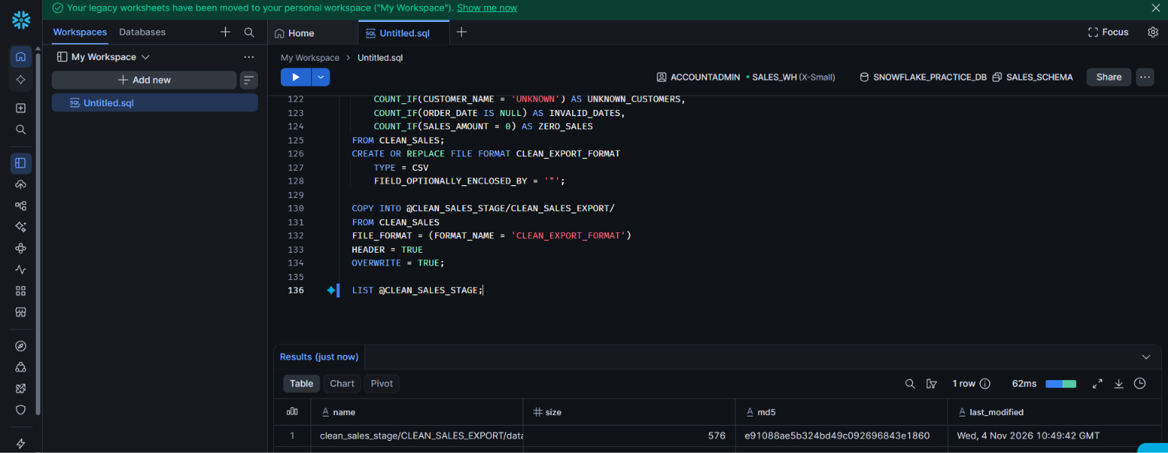
Analytics query
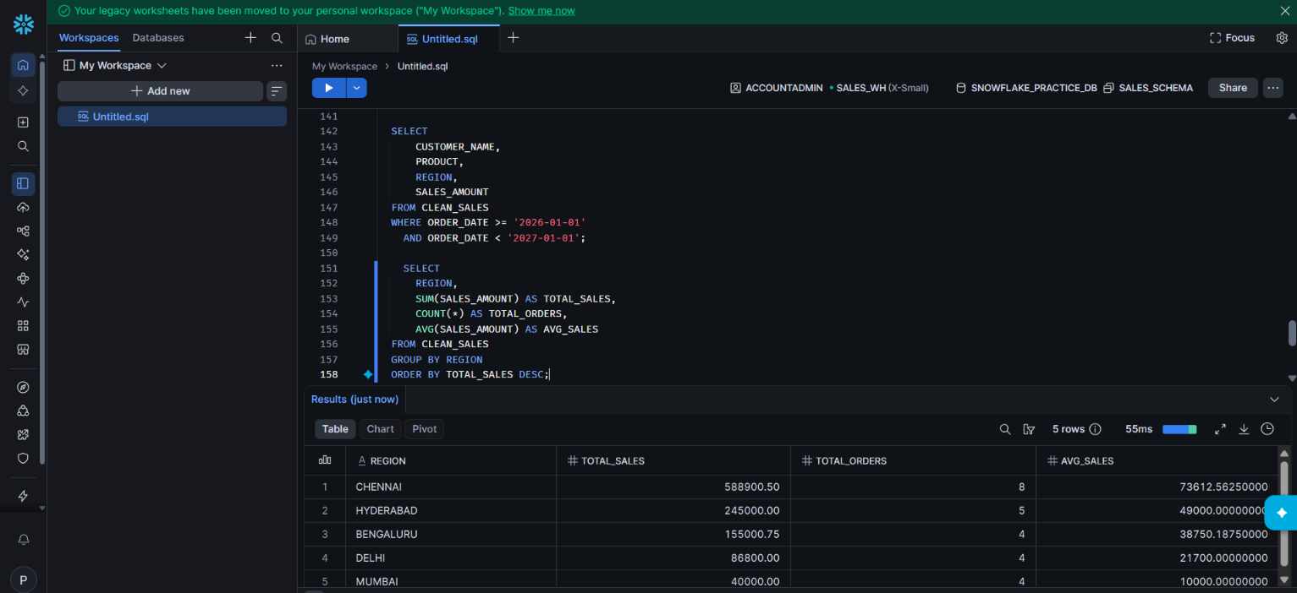
For query optimization running both the queries

Query a : SELECT *
FROM CLEAN_SALES
WHERE YEAR(ORDER_DATE) = 2026;
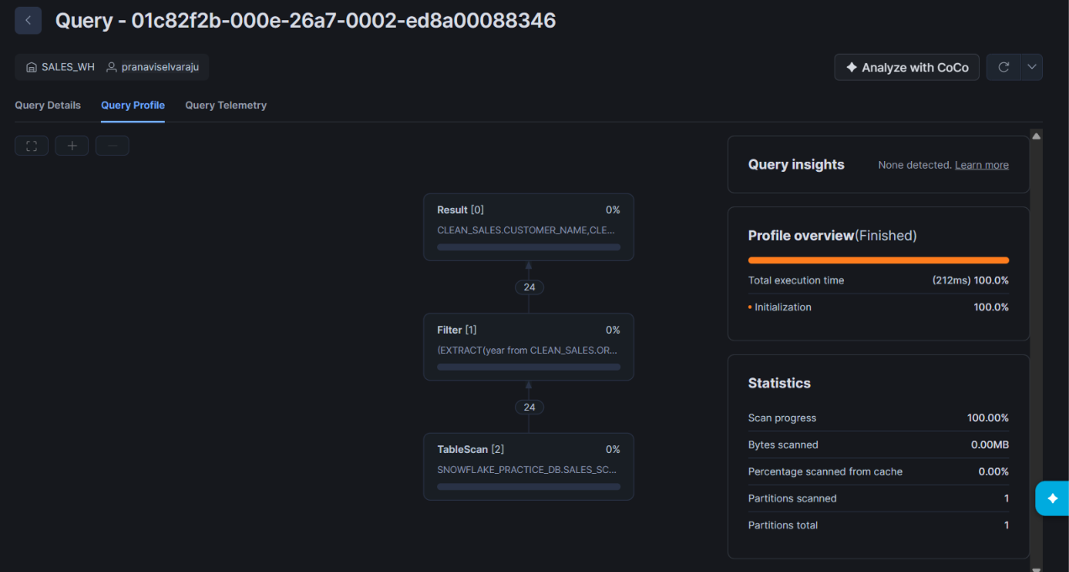

Query b :
SELECT
CUSTOMER_NAME,
PRODUCT,
REGION,
SALES_AMOUNT
FROM CLEAN_SALES
WHERE ORDER_DATE >= '2026-01-01'
AND ORDER_DATE < '2027-01-01';
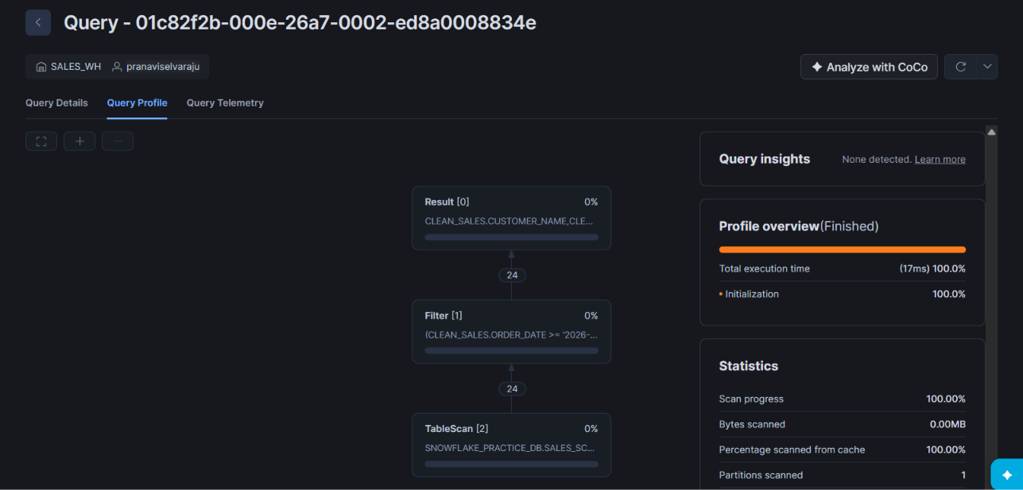
Query b is optimized
Compared using Query Profile

